**Functions & Pointers Problems**

1. Write a C program to input any number from user and find cube of the given number using function. How to find cube of a given number using function in C programming. Write a C function to find cube of a given number.

**Example**

**Input**

Input any number: 5

**Output**

Cube of 5 = 125

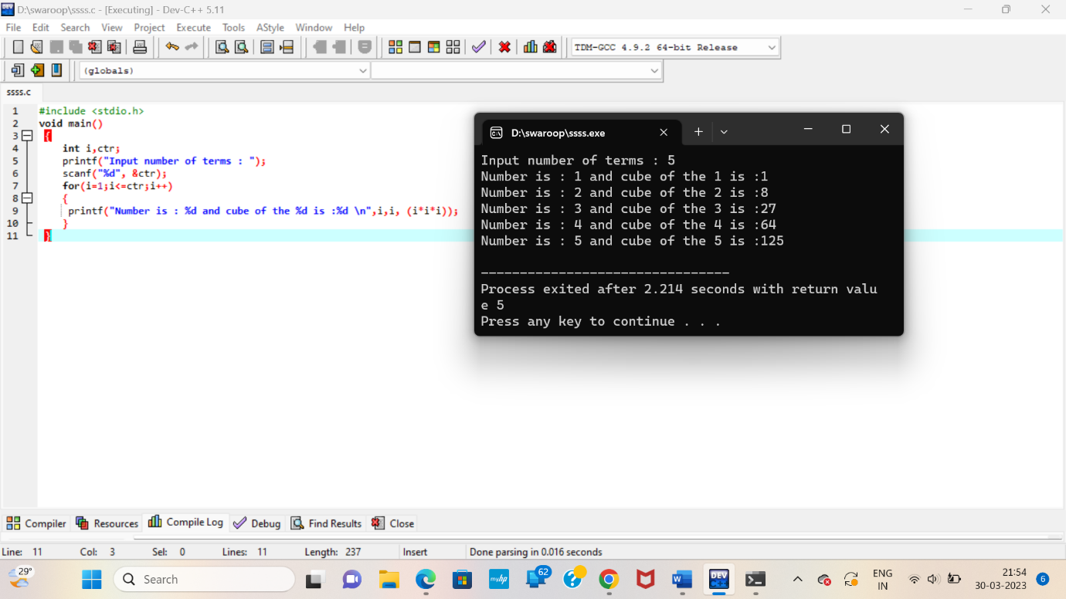

1. Write a C program to input radius of circle from user and find diameter, circumference and area of the given circle using function. How to find diameter, circumference and area of a circle using function in C programming.

**Example**

**Input**

Input radius: 10

**Output**

Diameter = 20 units

Circumference = 62.83 units

Area = 314.16 sq. units

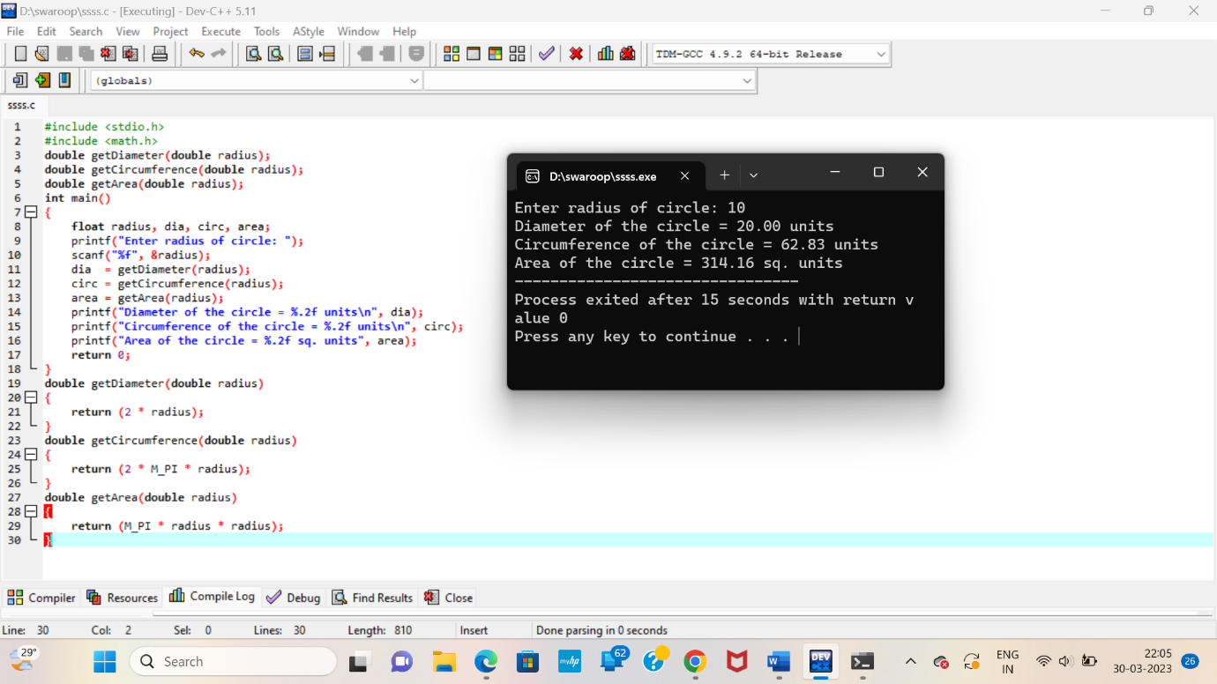

1. Write a C program to input two or more numbers from user and find maximum and minimum of the given numbers using functions. How to find maximum and minimum of two or more numbers using functions in C programming.

**Example**

**Input**

Input two numbers: 10

20

**Output**

Maximum = 20

Minimum = 10

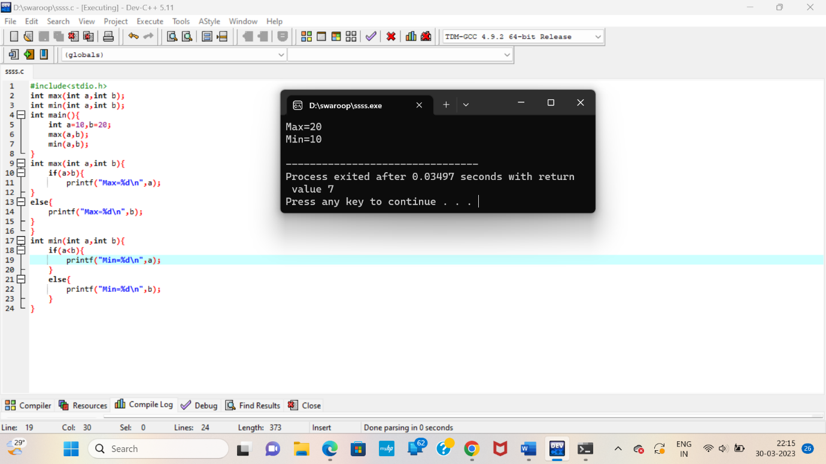

1. Write a C program to input a number from user and check whether given number is even or odd using functions. How to check even or odd using functions in C programming. Write a function in C programming to check even or odd.

**Example**

**Input**

Input any number: 10

**Output**

10 is even

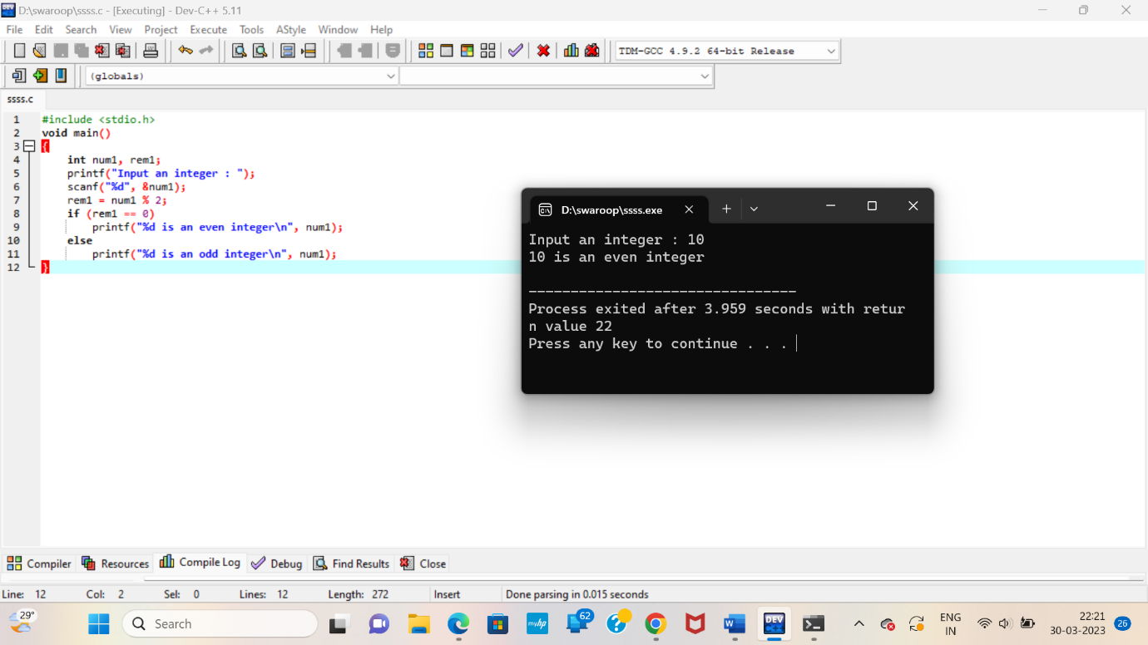

1. Write a C program to check whether a number is prime, armstrong, perfect number or not using functions. How to check prime or armstrong or perfect number in C programming using functions.

**Example**

**Input**

Input any number: 11

**Output**

11 is prime number

11 is not a armstrong number

11 is not a perfect number

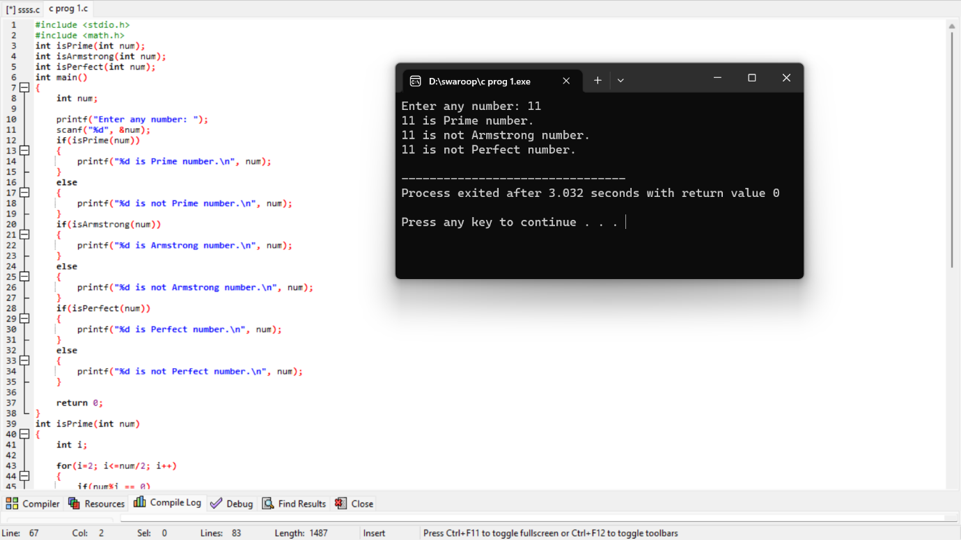

1. Write a function in C programming to find prime numbers using function. How to find all prime numbers between two intervals using functions. Display all prime numbers between a given range using function in C programming.

**Example**

**Input**

Input lower limit: 10

Input upper limit: 50

**Output**

Prime numbers between 10-50 are: 11, 13, 17, 19, 23, 29, 31, 37, 41, 43, 47

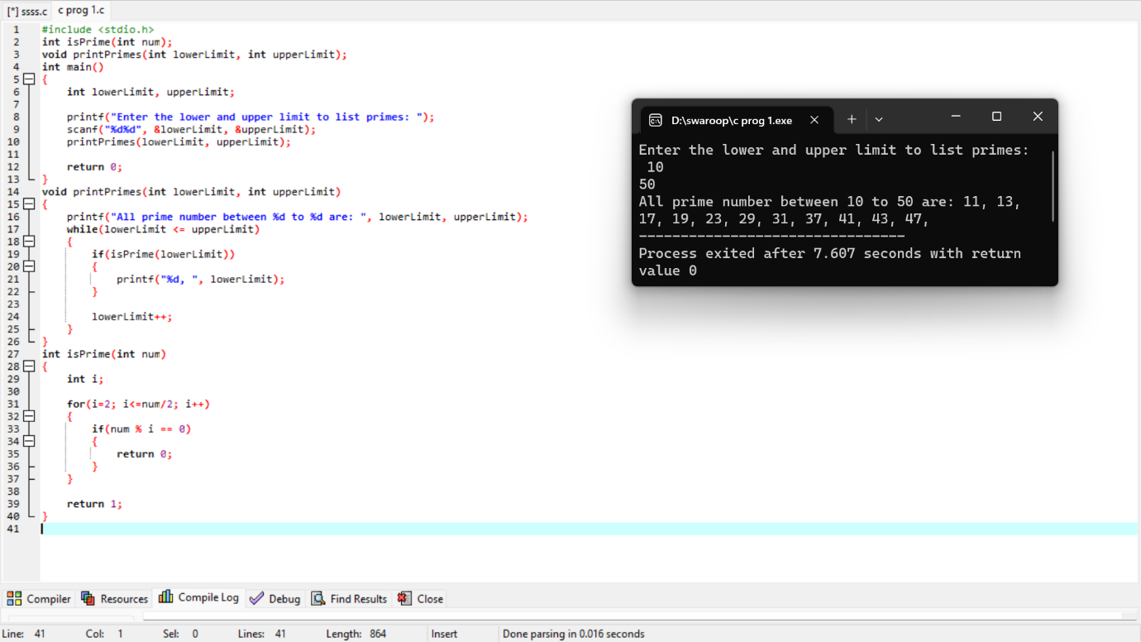

1. Write a C program to print all strong numbers between a given interval in C programming. How to print strong numbers in a given range using functions in C programming. Write a C function to find strong numbers between 1 to n.

**Example**

**Input**

Input lower limit: 1

Input upper limit: 1000

**Output**

Strong numbers between 1 to 100: 1, 2, 145

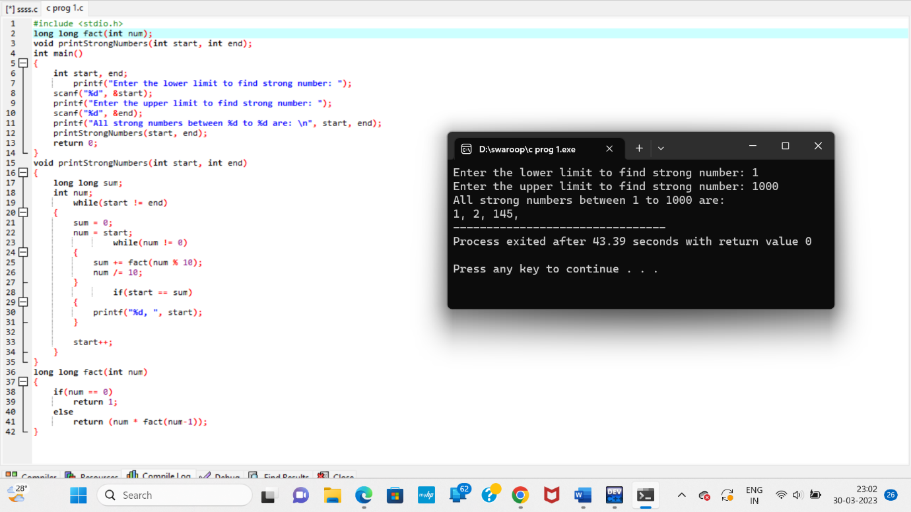

1. Write a function to print all Armstrong numbers between given interval in C programming. How to print all Armstrong numbers in given range using functions in C programming. C function to print all Armstrong numbers from 1 to n.

**Example**

**Input**

Input lower limit: 1

Input upper limit: 1000

**Output**

Armstrong numbers between 1 to 1000 are: 1, 153, 370, 371, 407,

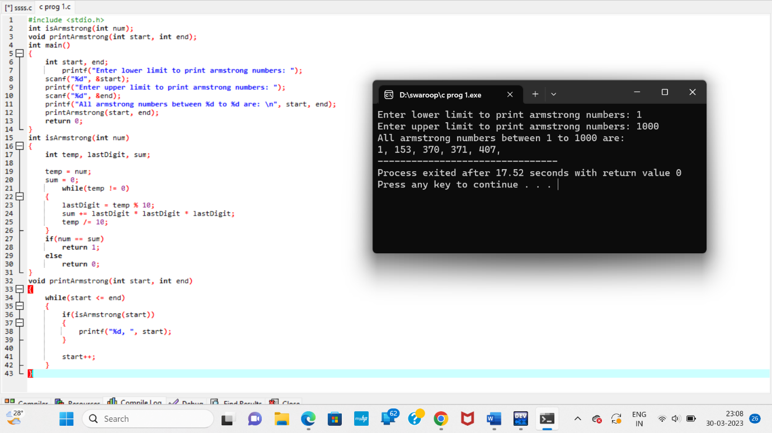

1. Write a function to print all perfect numbers in a given interval in C programming. How to print all perfect numbers in a given range using functions in C program. C program to print all perfect numbers between 1 to n using functions.

**Example**

**Input**

Input lower limit: 1

Input upper limit: 100

**Output**

Perfect numbers: 6, 28

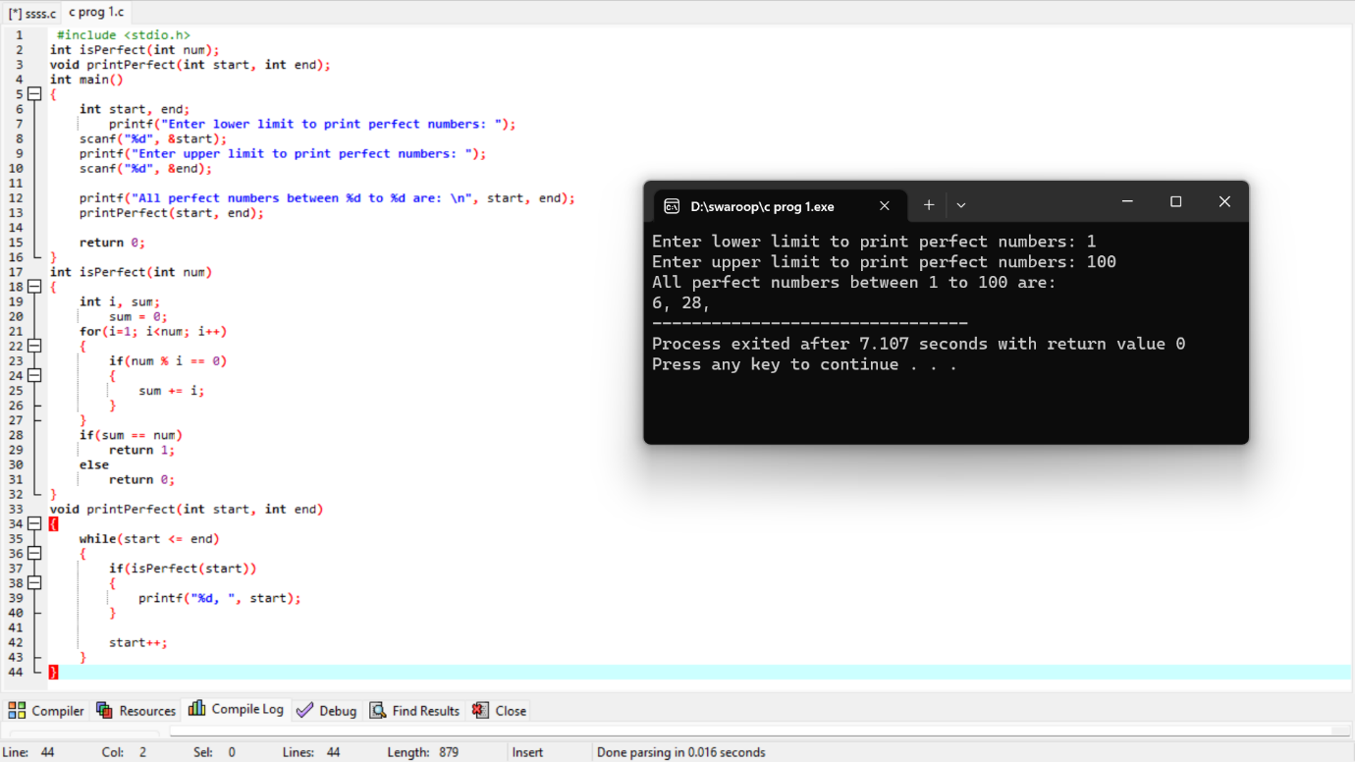

1. Write a C program to input a number from user and find power of given number using recursion. How to find power of a number using recursive function in C programming. Logic to find power of a number using recursion in C programming.

**Example**

**Input**

Input base number: 5

Input power: 2

**Output**

2 ^ 5 = 25

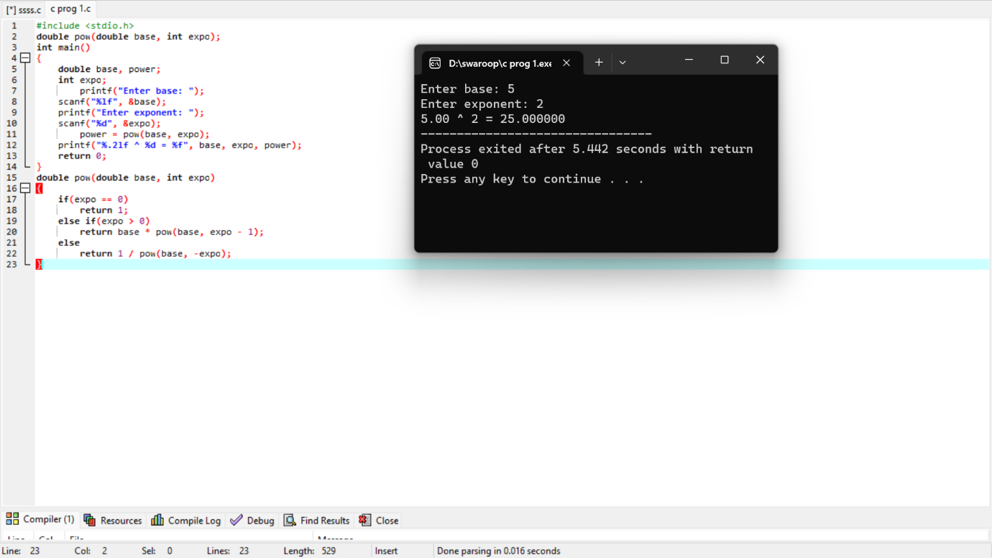

1. Write a recursive function in C programming to print all natural numbers between 1 to n. How to print all natural numbers from 1 to n using recursion in C program. Logic to print all natural numbers in given range using recursion in C programming.

**Example**

**Input**

Input lower limit: 1

Input upper limit: 10

**Output**

Natural numbers between 1 to 10: 1, 2, 3, 4, 5, 6, 7, 8, 9, 10,

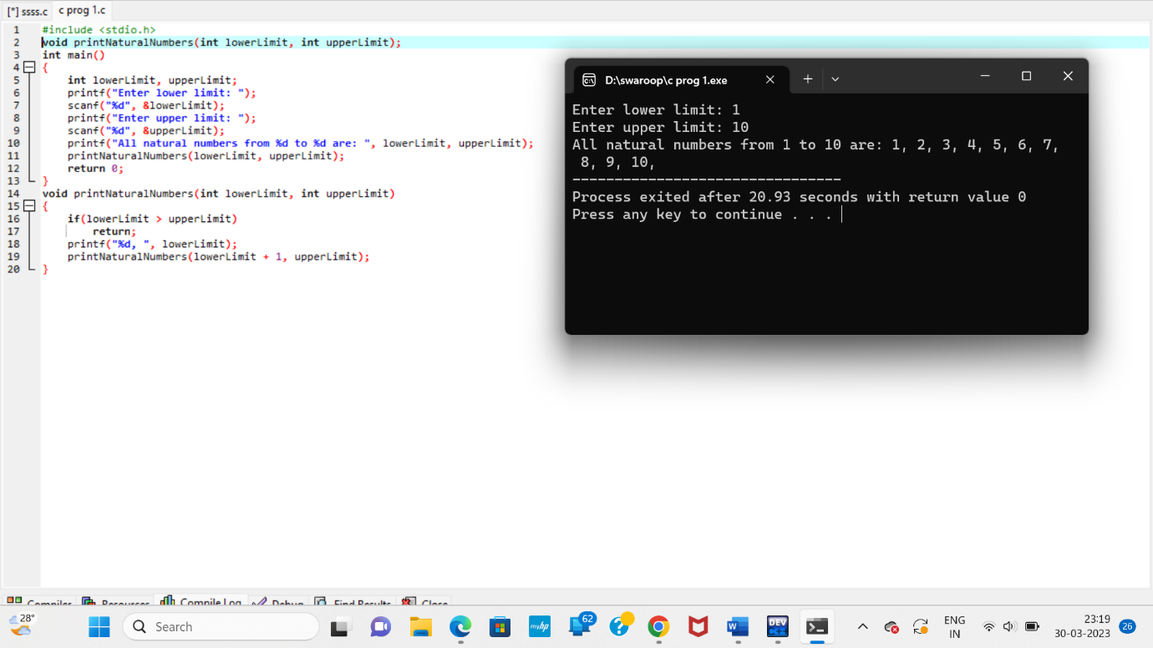

1. Write a recursive function in C programming to print all even or odd numbers between 1 to n. How to print all even numbers in given range using recursion in C programming. Logic to print even/odd numbers in given range using recursion.

**Example**

**Input**

Input lower limit: 1

Input upper limit: 10

**Output**

Even numbers between 1 to 10: 2, 4, 6, 8, 10

Odd numbers between 1 to 10: 1, 3, 5, 7, 9

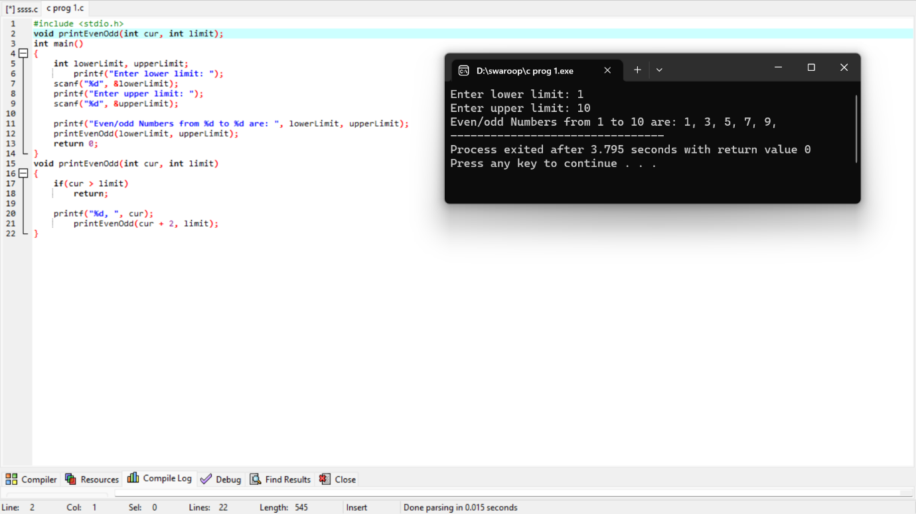

1. Write a recursive function in C programming to find sum of all natural numbers between 1 to n. How to find sum of all natural numbers using recursion in C program. Logic to find sum of natural numbers in given range using recursion.

**Example**

**Input**

Input lower limit: 1

Input upper limit: 10

**Output**

Sum of natural numbers from 1 to 10 = 55

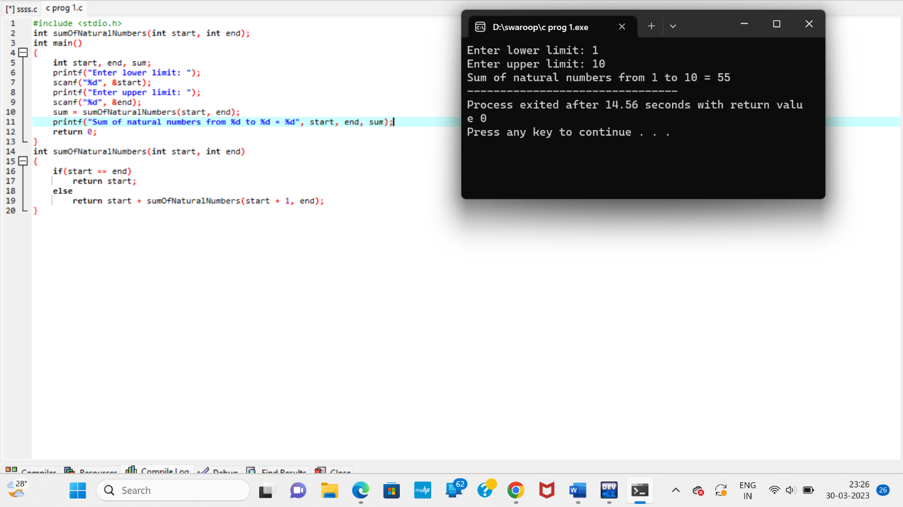

1. Write a recursive function in C to find sum of all even or odd numbers in a given range. How to find sum of all even numbers between 1 to n using recursion in C programming.

**Example**

**Input**

Input lower limit: 1

Input upper limit: 100

**Output**

Sum of even numbers between 1 to 100 = 2550

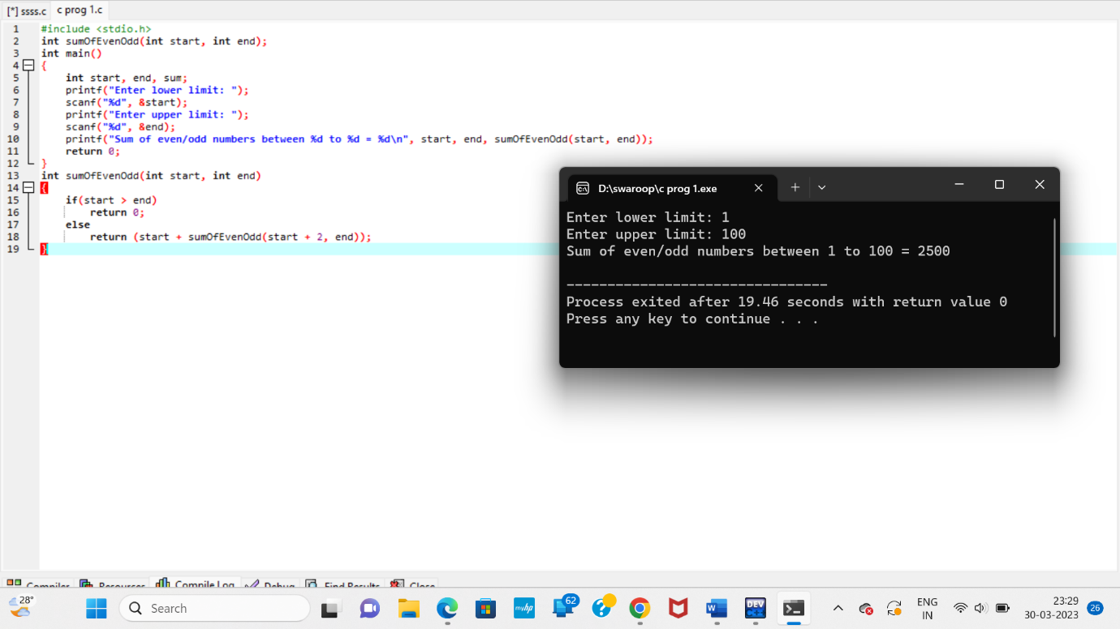

1. Write a recursive function in C programming to find reverse of a number. How to find reverse of a number in C programming using recursion. Logic to find reverse of a number using recursion in C programming.

**Example**

**Input**

Input number: 12345

**Output**

Reverse: 54321

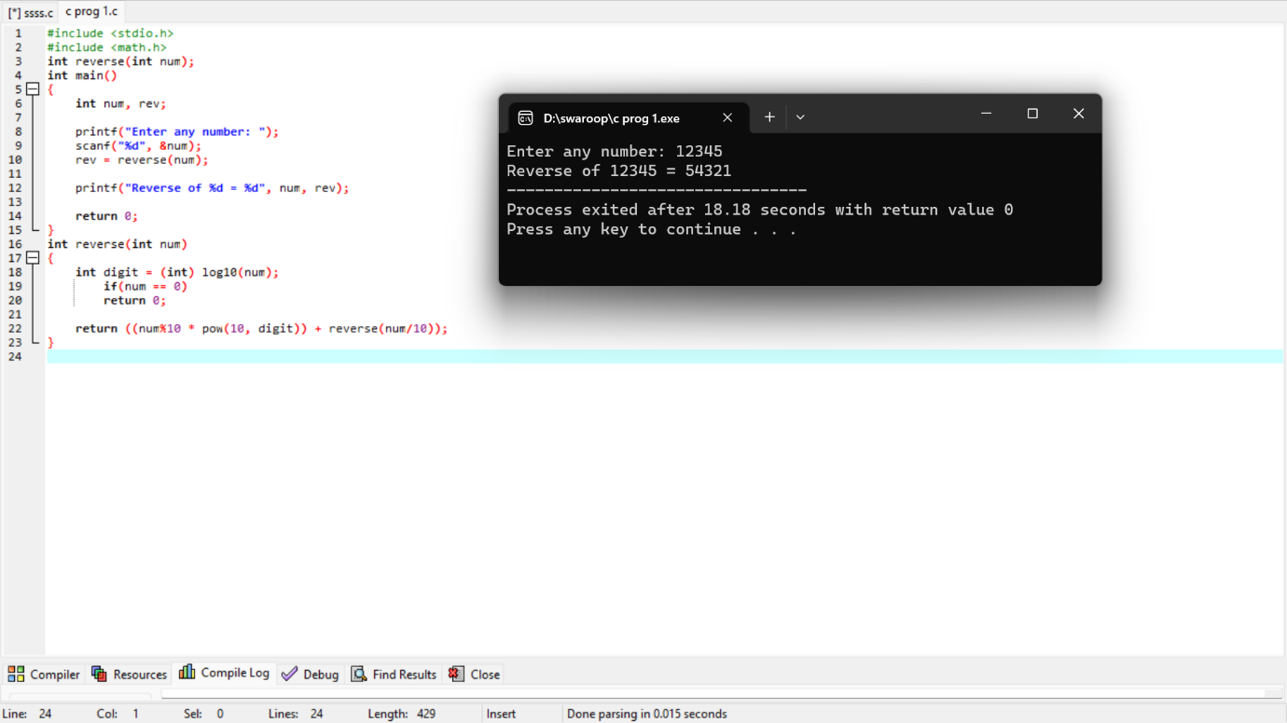

1. Write a recursive function in C to check palindrome number. How to check whether a number is palindrome or not using recursion in C program. Logic to check palindrome number using recursion in C programming.

**Example**

**Input**

Input number: 121

**Output**

121 is palindrome

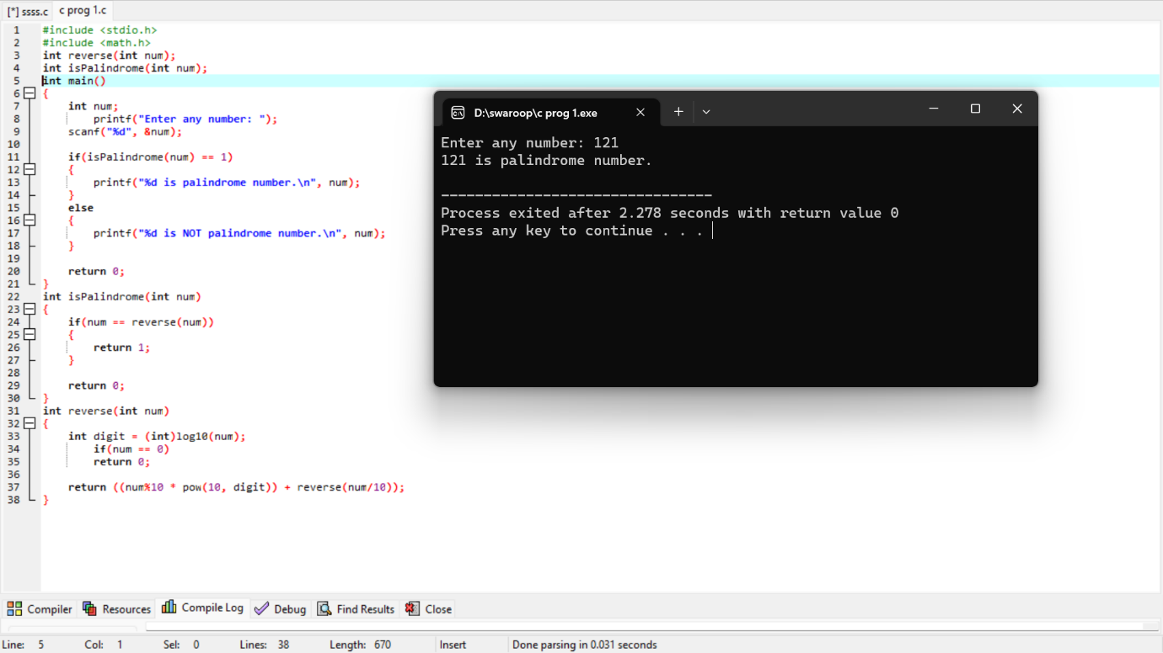

1. Write a recursive function in C programming to calculate sum of digits of a number. How to calculate sum of digits of a given number using recursion in C program. Logic to find sum of digits using recursion in C programming.

**Example**

**Input**

Input number: 1234

**Output**

Sum of digits: 10

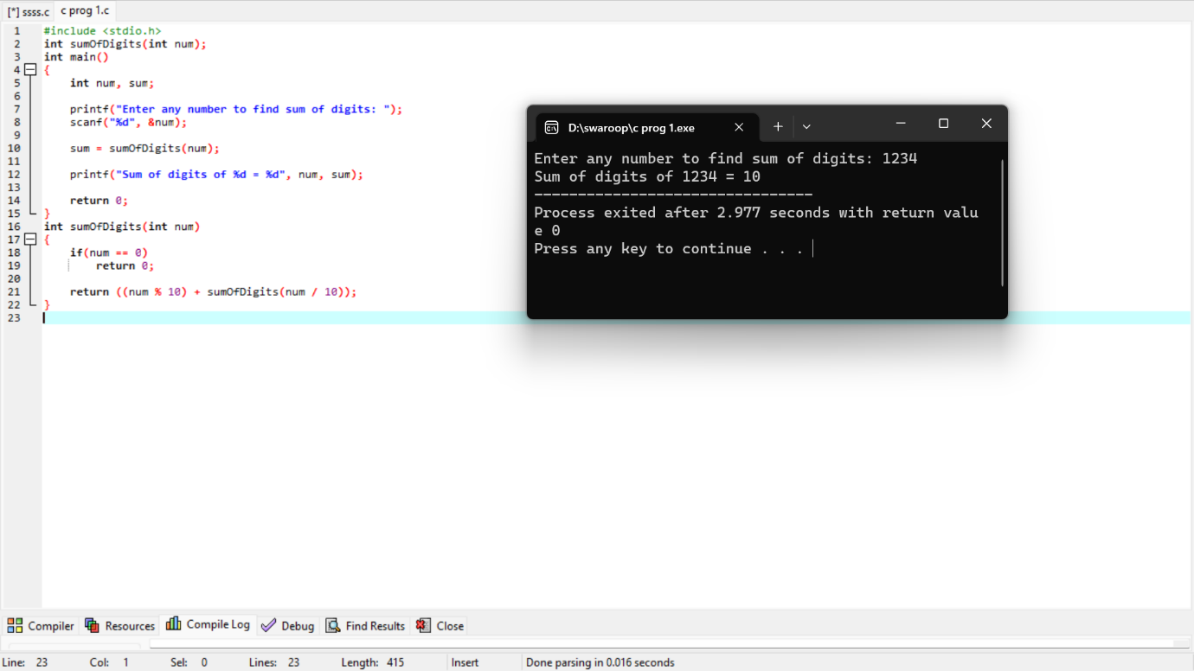

1. Write a C program to swap two numbers using pointers and functions. How to swap two numbers using call by reference method. Logic to swap two number using pointers in C program.

**Example**

**Input**

Input num1: 10

Input num2: 20

**Output**

Values after swapping:

Num1 = 20

Num2 = 10

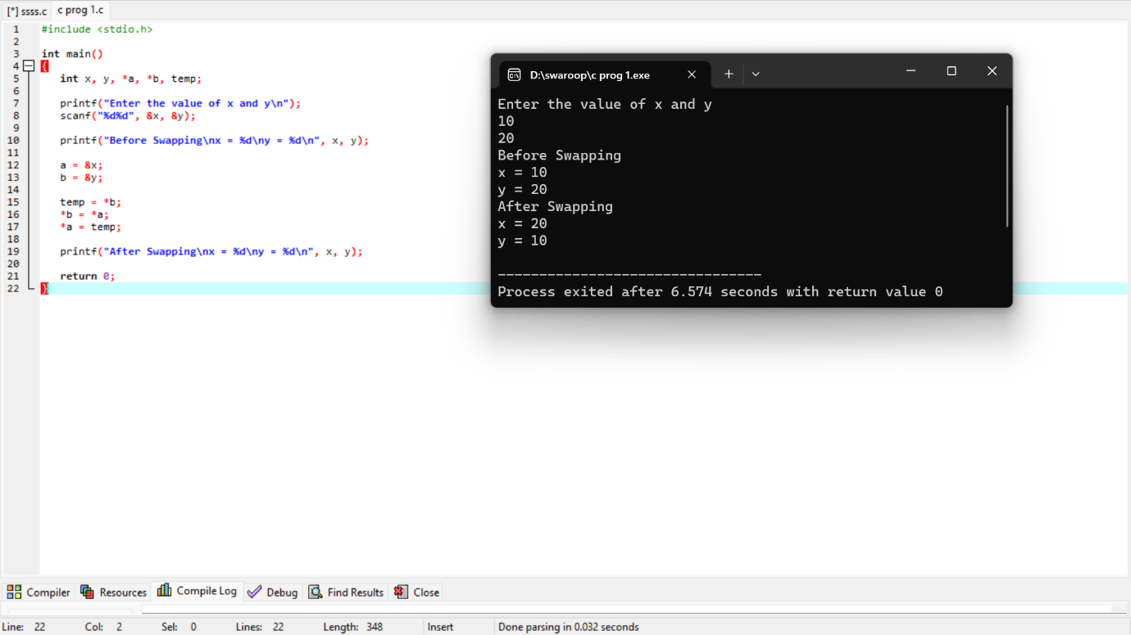

1. Write a C program to input elements in an array and print array using pointers. How to input and display array elements using pointer in C programming.

**Example**

**Input**

Input array size: 10

Input elements: 1

2

3

4

5

6

7

8

9

10

**Output**

Array elements: 1, 2, 3, 4, 5, 6, 7, 8, 9, 10

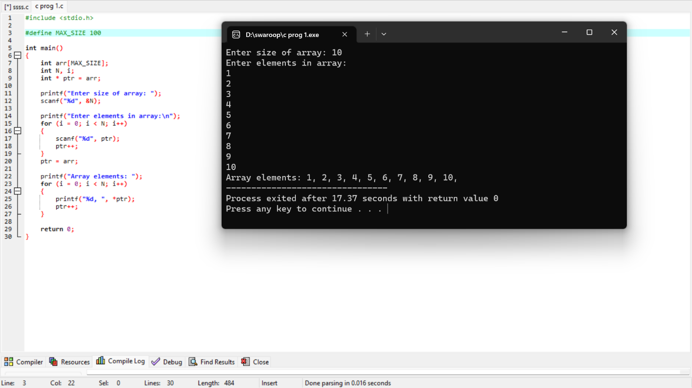

20. Write a C program to copy one array elements to another array using pointers. How to copy array elements from one array to another array using pointers. Logic to copy one array to another array using pointers in C programming.

**Example**

**Input**

Input array1 elements: 10 -1 100 90 87 0 15 10 20 30

**Output**

Array1: 10 -1 100 90 87 0 15 10 20 30

Array2: 10 -1 100 90 87 0 15 10 20 30

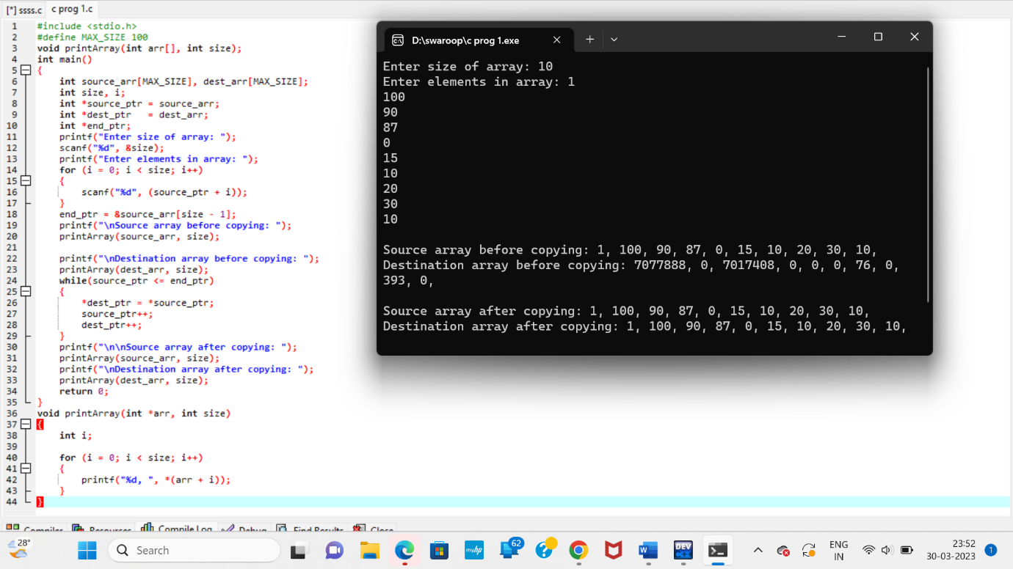

21. Write a C program to swap corresponding elements of two arrays using pointers. How to swap two arrays using pointers in C program. Logic to swap two arrays of different length using pointers in C programming.

**Example**

**Input**

Input first array: 10 20 30 40 50 60 70 80 90 100

Input second array: 0 9 8 7 6 5 4 3 2 1

**Output**

First array after swapping: 0 9 8 7 6 5 4 3 2 1

Second array after swapping: 10 20 30 40 50 60 70 80 90 100

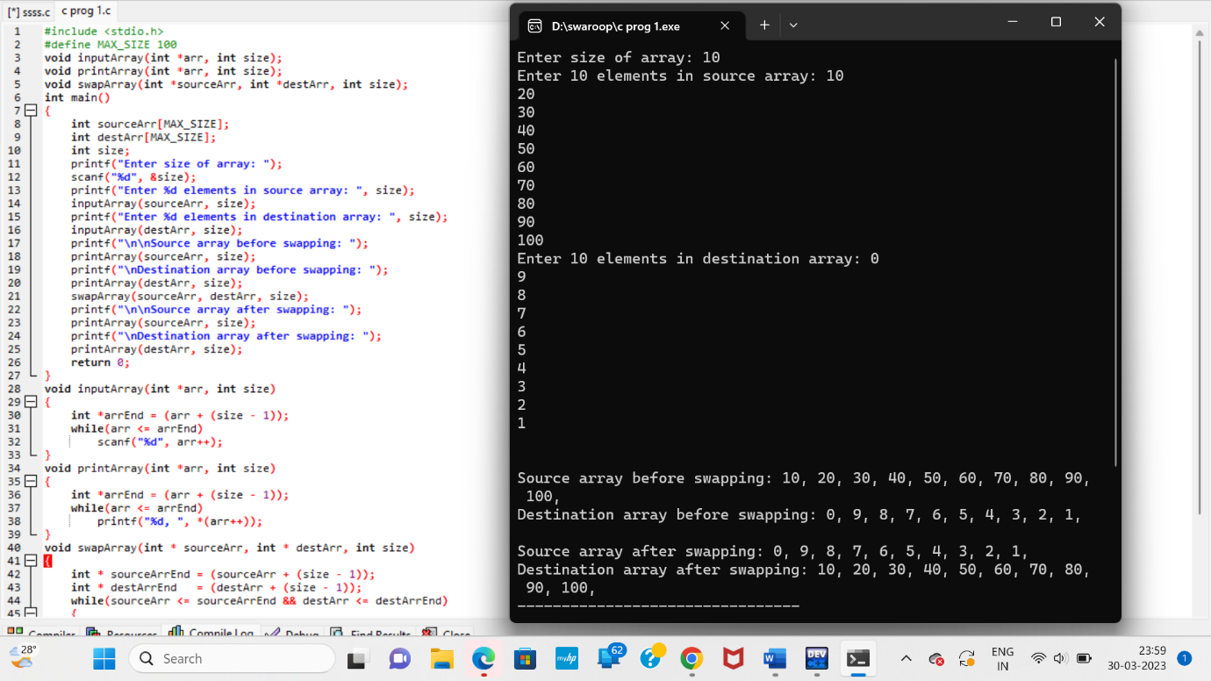

22. Write a C program to input elements in an array and reverse the array using pointers. How to reverse an array using pointers in C programming. Logic to reverse an array using pointers in C.

**Example**

**Input**

Input array elements: 10 20 30 40 50 60 70 80 90 100

**Output**

Reversed array: 100 90 80 70 60 50 40 30 20 10

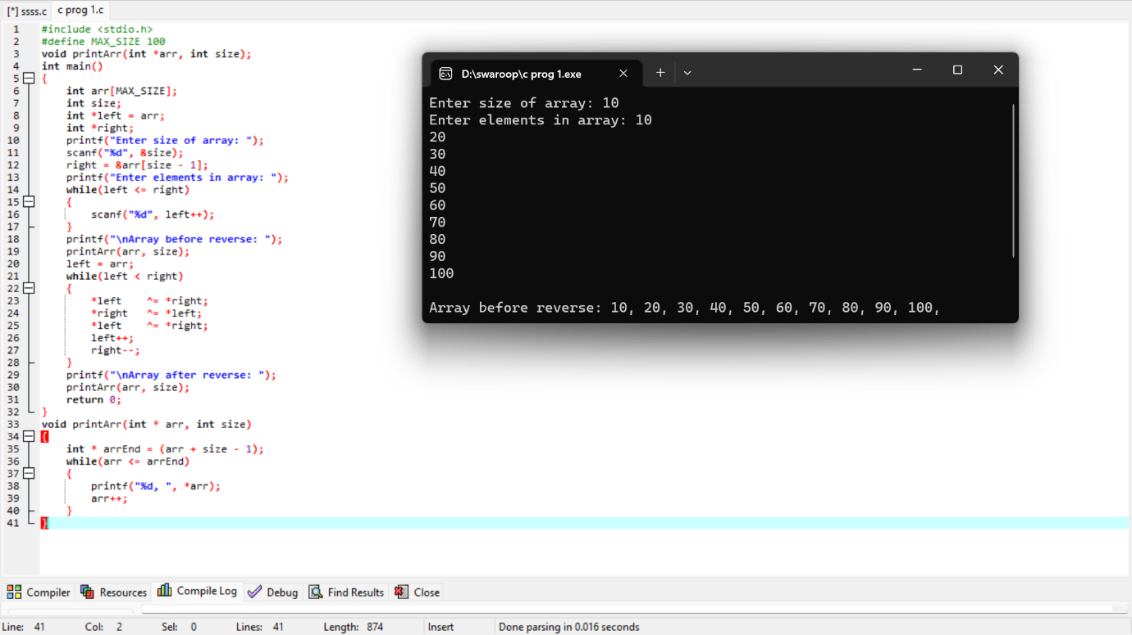

23. Write a C program to input elements in array and search an element in array using pointers. How to search an element in array using pointers in C programming. Logic to search an element in array using pointers in C program.

**Example**

**Input**

Input array elements: 10 20 30 40 50 60 70 80 90 100

Input element to search: 25

**Output**

25 does not exists in array.

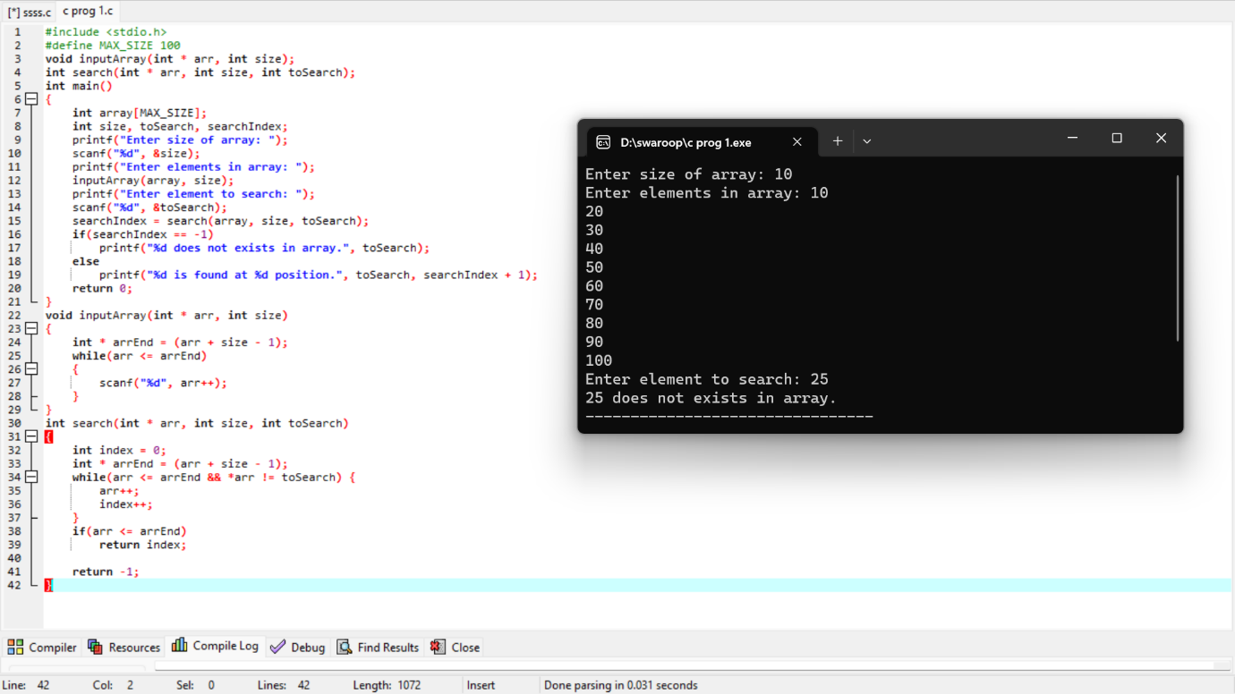

24. How to access two dimensional array using pointers in C programming? Write a C program to input and print elements of a two dimensional array using pointers and functions.

**Example**

**Input**

Input elements in 3x3 matrix:

1 2 3

4 5 6

7 8 9

**Output**

Elements of 3x3 matrix:

1 2 3

4 5 6

7 8 9

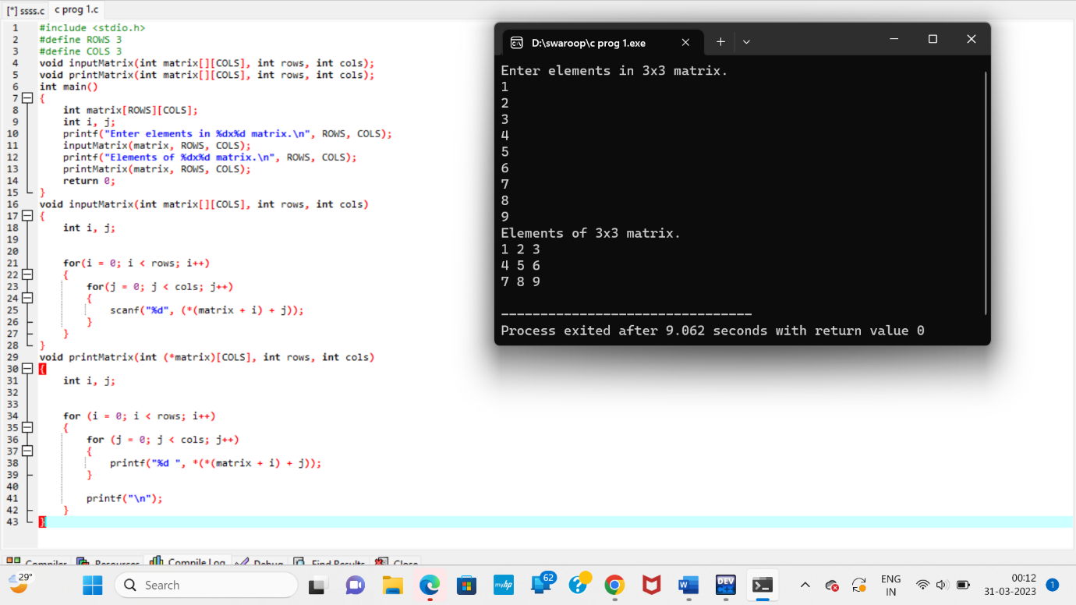

25. Write a C program to input elements in an array and sort array using pointers. How to sort an array in ascending or descending order using function pointers in C programming. Logic to sort an array using pointers in program.

**Example**

**Input**

Input array elements: 10 -1 0 4 2 100 15 20 24 -5

**Output**

Array in ascending order: -5, -1, 0, 2, 4, 10, 15, 20, 24, 100,

Array in descending order: 100, 24, 20, 15, 10, 4, 2, 0, -1, -5,

